Answers are in blue.

# For Exercises 1–14, mark the answers true and false as follows:

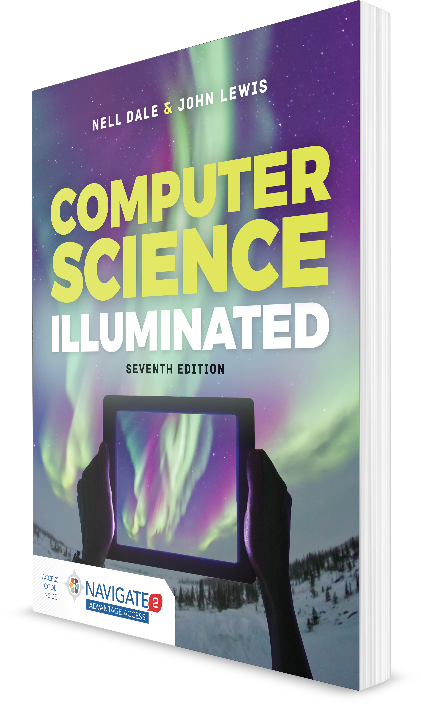

**Computer Science Illuminated, Seventh Edition**

Nell Dale, PhD; John Lewis, PhD

**CHAPTER 16**

EXERCISES AND ANSWERS

1. **True**
2. **False**
   1. The Internet and the Web are essentially two names for the same thing.

B

* 1. The computer that is set up to respond to web requests is a web browser.

B (it’s a web server)

* 1. When we visit a website, we actually bring the site to us. A
  2. Most search engines use a context-based approach for find- ing candidate pages.

B

* 1. A weblog is the same thing as a blog. A
  2. A weblog can serve as a online publication for “citizen journalists.”

A

* 1. A cookie is a program that is executed on your computer. B (most use keyword matching)
  2. All elements associated with a particular web page are brought over when a request for that web page is made.

A

* 1. HTML and CSS are often used together. A
  2. CSS is used to specify the content of a web page. B
  3. Networks have been used to connect computers since the 1950s.

A

* 1. Network communication was not possible until the advent of the Web.

B

* 1. The Web was developed in the mid-1990s. A
  2. You must have a web browser in order to access the Web. A

# For Exercises 15–24, match the word or acronym with the definition or blank.

1. **JSP scriptlet**
2. **URL**
3. **HTML**
4. **Tag**
5. **Java applet**
6. **XML**
   1. A program designed to be embedded into an HTML document.

E

* 1. Uniquely identifies every web page. B
  2. runs on the web server. A
  3. runs on the web browser. E
  4. Tags in are fixed. C
  5. Tags in are not predefined. F
  6. is a metalanguage. F
  7. The structure of a(n) document is described by its corresponding Document Type Definition (DTD).

F

* 1. The syntactic element in a markup language that indicates how information should be displayed.

D

* 1. Part of a(n) is the host name of the computer on which the information is stored.

B

# Exercises 25–76 are problems or short-answer questions.

* 1. What is the Internet?

The Internet is a wide-area network spanning the globe.

* 1. What is the Web?

The Web is an infrastructure of distributed information com- bined with the software that uses networks as a vehicle to exchange that information.

* 1. What is a web page?

A web page is a document that contains or references various kinds of data, such as text, images, graphics, and programs.

* 1. What is a website?

A website is a collection of related web pages, usually designed and controlled by the same person or company.

* 1. What is a link in the context of the Web?

A link is a connection between one web page and another.

* 1. Why is a spiderweb a good analogy for the World Wide Web? The Internet is the hardware upon which the spider-like con- nections of the World Wide Web have been created.
  2. What is the relationship between a web page and a website? A web page is a document that contains or references var- ious kinds of data. A website is a collection of related web pages.
  3. What is the difference between the Internet and the Web? The Internet is a wide-area network that spans the Earth. The Web is the infrastructure of distributed information and net- work software that lets us use the Internet more easily.
  4. Describe how a web page is retrieved and viewed by a web user.

When a web address is specified in a browser, the browser sends a request to that site. The site receiving the request sends the page and all associated information back to be displayed in the browser.

* 1. What is a Uniform Resource Locator?

A Uniform Resource Locator (URL) is the standard way of specifying the location of a web page.

* 1. What is a markup language? Where does the name come from?

A markup language is one that uses tags to identify the ele- ments in a document and indicate how they should be dis- played. The name comes from the idea of taking a document and writing (marking up) the document with tags that say how to display it.

* 1. Compare and contrast hypertext and hypermedia. Hypertext and hypermedia both mean that data (informa- tion) are not organized linearly. There are embedded links that allow us to jump from one place to another in docu- ments. Because information on the Web is more than just text, hypermedia is a more accurate term.
  2. Describe the syntax of an HTML tag.

HTML tags are composed of reserved words enclosed in angled brackets (<...>). Some reserved words are used in pairs with the second one preceded by a /.

* 1. What is a horizontal rule? What are they useful for? Horizontal rules are lines across a page. They are useful for separating sections of a page.
  2. What is a tag attribute? Give an example.

A tag attribute is part of a tag that gives extra information.

<img src = “picture.jpg”> is an example. The tag is *img* for image, and the attribute is *src* for source of image, which is followed by the name of a file containing the image in quotes.

* 1. Write the HTML statement that inputs the image on file “mine.gif” into the web page.

<img scr = “mine.gif”>

* 1. Write the HTML statement that sets up a link to [http://www](http://www/)

.cs.utexas.edu/users/ndale/ and shows the text “Dale Home Page” on the screen.

<A HREF = “<http://www.cs.utexas.edu/users/> ndale”> Dale Home Page </A>

* 1. What happens when a user clicks on “Dale Home Page” as set up in Exercise 41?

A copy of the page at <http://www.cs.utexas.edu/users/ndale> is displayed on the user’s browser.

* 1. Which CSS style rule would you use to horizontally center a line of text?

Assuming that the line of text is a distinct HTML ele- ment, the simplest way is to add the attribute style=“text-align:center” to the element. However, it is better design to apply a class attribute and then define a CSS rule for the class.

* 1. What are the three ways in which CSS style rules can be expressed for a web page?

CSS style rules can be expressed in external CSS style sheets, as

<style> elements (usually within a page’s <head> element) or as tag attributes.

* 1. Design and implement an HTML document for an organiza- tion at your school.

Activity, no answer expected.

* 1. Design and implement an HTML document describing one or more of your personal hobbies.

Activity, no answer expected.

* 1. What is a Java applet?

A Java applet is a Java program designed to be embedded in an HTML document, transferred over the Web, and exe- cuted in a browser.

* 1. How do you embed a Java applet in an HTML document?

A Java applet is embedded in an HTML document using the applet tag. For example, the following HTML tag embeds class MyClass in an HTML document:

<APPLET code=”MyClass.class” width=250 height=150 ></APPLET>

* 1. Where does a Java applet get executed?

A Java applet gets executed in the user’s browser.

* 1. What kinds of restrictions are put on Java applets? Why? Because a Java applet is executed on the user’s machine, it must be transmitted from the web server. Also, the user’s computer may not have a resource that the applet needs. Thus only relatively small programs using very standard resources are appropriate.
  2. What is a Java Server Page?

A Java Server Page (JPS) is a web page that has Java scriptlets embedded in it.

* 1. What is a scriptlet?

A scriptlet is a code segment embedded in an HTML doc- ument designed to contribute to the content of the page.

* 1. How do you embed a scriptlet in an HTML document? The special HTML tags <%..%> enclose the scriptlet.
  2. How does JSP processing differ from applet processing? Scriptlet processing is done on the server side; applet pro- cessing is done on the user’s side.
  3. What is a metalanguage?

A metalanguage is a language used to define other languages.

* 1. What is XML?

XML is a metalanguage that is used to define other markup languages.

* 1. How and HTML and XML alike, and how are they different? Both HTML and XML used tagged data. The tags that HTML uses are predefined, both in terms of syntax and semantics. XML is a metalanguage that defines new markup languages. An XML document is written using tags, which are then defined in the accompanying Document Type Definition.
  2. How does an XML document relate to a Document Type Definition?

The XML document and the related DTD define a new markup language.

* 1. A. In a DTD, how do you indicate that an element is to be repeated zero or more times?

An element in parentheses with an asterisk following the element indicates zero or more times.

* 1. In a DTD, how do you indicate that an element is to be repeated one or more times?

An element in parentheses with a plus sign following the element indicates one or more times.

* 1. In a DTD, how do you indicate that an element cannot be broken down into other tags?

An element followed by (#PCDATA) indicates that the element cannot be broken down further.

* 1. What is XSL?

XSL stands for Extensible Stylesheet Language. XSL is used to define transformations of XML documents to other formats.

* 1. What is the relationship between XML and XSL?

XSL is the language that can be used to determine formats for an XML document and its accompanying DTD.

* 1. How does an XML document get viewed?

An XML document is translated by XSL into a form that can be displayed.

* 1. Define an XML language (the DTD) for your school courses and produce a sample XML document.

<?xml version=”1.0” ?>

<!DOCTYPE courses SYSTEM “courses.dtd”>

<courses>

<course>

<title>Analysis of Algorithms</title>

<department>Computer Science</department>

<courseNumber>170</courseNumber>

<instructor>Smyth</instructor>

</course>

<courses>

<title>The American Revolution</title>

<department>History</department>

<courseNumber>240</courseNumber>

<instructor>Jefferson</instructor>

</course>

<courses>

<title>Spanish Poetry</title>

<department>Spanish</department>

<courseNumber>470</courseNumber>

<instructor>Garcia</instructor>

</course>

</courses>

<!ELEMENT courses (course*) >

<!ELEMENT course (title, department, courseNumber, instructor)>

<!ELEMENT title (#PCDATA)>

<!ELEMENT department (#PCDATA)>

<!ELEMENT courseNumber (#PCDATA)>

<!ELEMENT instructor (#PCDATA)>

* 1. Define an XML language (the DTD) for political offices and produce a sample XML document.

<?xml version=”1.0” ?>

<!DOCTYPE government SYSTEM “government.dtd”>

<government>

<position>

<title>President of the United States</title>

<type>Federal</type>

<currentHolder>

<name>George W. Bush</name>

<party>Republican</party>

</currentHolder>

<pastHolders>

<name>William Clinton</name>

<name>George H. W. Bush</name>

<name>Ronald Reagan</name>

<name>James Carter</name>

</pastHolders>

</position>

<position>

<title>Vice President of the United States</ title>

<type>Federal</type>

<currentHolder>

<name>Richard Cheney</name>

<party>Republican</party>

</currentHolder>

<pastHolders>

<name>Al Gore</name>

<name>Dan Quayle</name>

<name>George H. W. Bush</name>

<name>Walter Mondale</name>

</pastHolders>

</position>

</government>

<!ELEMENT government (position*) >

<!ELEMENT position (title, type, curr- entHolder, pastHolders)>

<!ELEMENT title (#PCDATA)>

<!ELEMENT type (#PCDATA)>

<!ELEMENT currentHolder (name, party)>

<!ELEMENT pastHolders (name*)>

<!ELEMENT name (#PCDATA)>

<!ELEMENT party (#PCDATA)>

* 1. Define an XML language (the DTD) for zoo animals and pro- duce a sample XML document.

<?xml version=”1.0” ?>

<!DOCTYPE animals SYSTEM “animals.dtd”>

<animals>

<animal>

<commonName>kangaroo</commonName>

<class>mammalia</class>

<order>marsupialia</order>

<onSite>

<male>

<number>2</number>

<name>Cletus</name>

<name>Nate</name>

</male>

<female>

<number>0</number>

</female>

</onSite>

</animal>

<animal>

<commonName>elephant</commonName>

<class>mammalia</class>

<order>elephantidae</order>

<onSite>

<male>

<number>1</number>

<name>Max</name>

</male>

<female>

<number>2</number>

<name>Beauty</name>

<name>Geraldine</name>

</female>

</onSite>

</animal>

<animal>

<commonName>alligator</commonName>

<class>reptilia</class>

<order>crocodilia</order>

<onSite>

<male>

<number>4</number>

</male>

<female>

<number>7</number>

</female>

</onSite>

</animal>

</animals>

<!ELEMENT animals (animal*) >

<!ELEMENT animal (commonName, class, order, onSite)>

<!ELEMENT commonName (#PCDATA)>

<!ELEMENT class (#PCDATA)>

<!ELEMENT order (#PCDATA)>

<!ELEMENT onSite (male, female)>

<!ELEMENT male (number, name*)>

<!ELEMENT female (number, name*)>

<!ELEMENT number (#PCDATA)>

<!ELEMENT name (#PCDATA)>

* 1. This chapter is full of acronyms. Define each of the following ones.
     1. HTML

Hypertext Markup Language

* + 1. XML

Extensible Markup Language

* + 1. DTD

Document Type Definitions

* + 1. XSL

Extensible Stylesheet Language

* + 1. SGML

Standard Generalized Markup Language

* + 1. URL

Uniform Resource Locator

* + 1. ISP

Internet Service Provider

* 1. Create an HTML document for a web page that has each of the following features.
     1. Centered title
     2. Unordered list
     3. Ordered list
     4. Link to another web page
     5. A picture

Activity; no answer expected.

* 1. Distinguish between an HTML tag and an attribute.

A tag is a syntactic element in a markup language that indi- cates how information should be displayed. An attribute is part of a tag that gives additional information about it.

* 1. Why might the same web page look different in different browsers?

The tags in the HTML document that defines a web page may be interpreted differently by different browsers.

* 1. What are the two sections of every HTML document?

The head of the document and the body of the document.

* 1. What are the contents of the two parts of an HTML document? The head contains information about the document. The body contains the information to be displayed.
  2. What does the A stand for in the tag that specifies a URL for a page?

Anchor

* 1. Create an HTML document for a web page that has each of the following features.
     1. A right-justified title in large type font
     2. An applet class named “Exercise.class”.
     3. Two different links
     4. Two different pictures Activity; no answer provided.
  2. Which social networking site currently has the most users? Facebook currently has the most users of any social network- ing site.
  3. What is the *small world phenomenon*?

The hypothesis that the chain of social acquaintances neces- sary to connect any two arbitrary people is generally short.

* 1. What did the term “social network” mean before the online version we know today became popular?

A social network is a model of how objects—individuals or organizations—interact.